Worksheet 3 - Asteroid Shoot-em Up
Aims: To program a meteor that will appear coming towards the ship

- Load up your Asteroids game.

- Locate the ‘Rock’ files and save them to your folders. You need to import these files to the library.
a. Select File>Import>Import to stage…
b. Then find the files and select them. Then press ‘Open’.
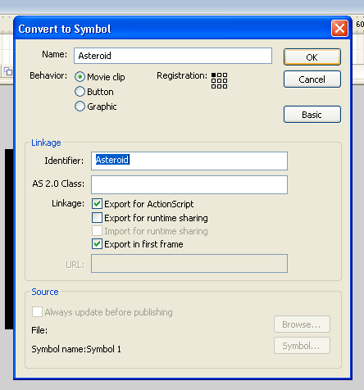

- Select the ‘Rock’ image, by clicking on it. Then go to Modify>convert to symbol. You may need to select the advanced button.

- Next, we need to name the symbol Asteroid
- Ensure the button ‘Movie Clip’ is ticked.
- Click on ‘Basic’
- Tick the ‘Export for ActionScript’ box
- The menu should look like this. If it does then click ‘OK’.

- Double-click on the Asteroid. Right click on your image and choose break apart. Using the transform tool (q) or lasso tool (l) select small sections of your image and move them away from the original image. This creates the individual sections for your puzzle.
- Next, we need to convert each section of the Asteroid to a movie clip
- Select each piece of the Asteroid and press F8
- Give the symbol an appropriate name
- Ensure the button ‘Movie Clip’ is ticked.
- Click ‘OK’.

- Highlight all the different images of the Asteroid. Go to Modify>Timeline>Distribute to Layers. This will put each individual section of the Asteroid on its own layer.

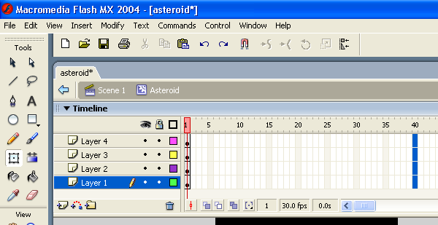
- Highlight all 4 layers of frame 40

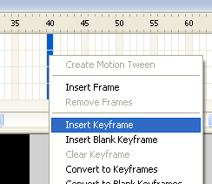
- Right click on frame 40 and select ‘Insert Keyframe’

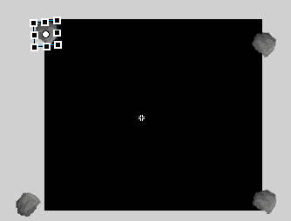
- Select each rock and move them one-by-one to opposite corners of the screen.

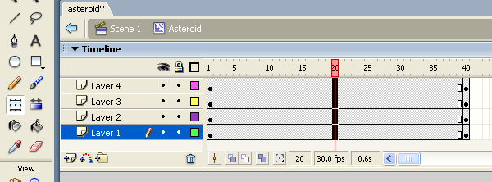
- Highlight all 4 layers of frame 20

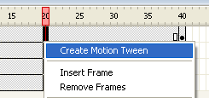
- Right click on frame 20 and select Create Motion Tween

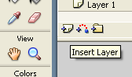
- Insert a new layer

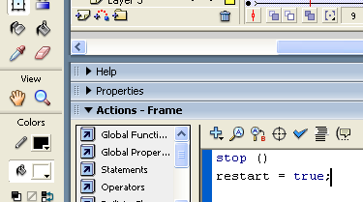
- Load up the Action – Frame properties and type the following code

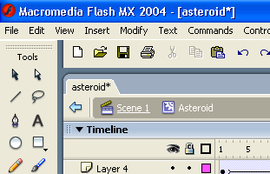
- Click back on Scene 1 to go back to the game.

- Select the Shoot layer and load up the Action – Frame property bar. Enter the following code that has a BLACK background and WHITE text.

- Go to Control and Test Scene to see if the ship moves from left to right and up and down.
var bulletSpeed = 9;
var bulletReady = true;
var bulletDelay = 150;
var bulletArray = [];
var bulletCount = 0;
function createBullets(){
var bulletMc = this.attachMovie("bullet1", "bullet1"+bulletCount, 1000+bulletCount);
bulletCount++;
bulletMc._x = shipMc._x+(shipMc._width/2)-(bulletMc._width/2);
bulletMc._y = shipMc._y+bulletMc._height;
bulletArray.push(bulletMc);
}
function moveBullets(){
if(bulletReady && Key.isDown(Key.SPACE)){
trace(bulletArray.length);
bulletReady = false;
currentTime = getTimer();
createBullets();
} else {
if(currentTime+bulletDelay<=getTimer()){
bulletReady = true
}
}
for(var i = 0; i<bulletArray.length; i++){
var b = bulletArray[i];
if (b._y>-50) {
b._y -= bulletSpeed;
} else {
removeMovieClip(b);
bulletArray.splice(i, 1);
}
if (!hit) {
if(b.hitTest(ob)) {
hit = true;
ob.play();
removeMovieClip(b);
bulletArray.splice(i, 1);
}
}
}
}
var hit = false;
var obSpeed = 2;
function createObject(o) {
ob = this.attachMovie(o, o, 100);
ob._x = random(180)+20;
}
function resetObject() {
ob._x = random(180)+20;
ob._y = -40;
ob.gotoAndStop(1);
ob.restart = false;
hit = false
}
function moveObject() {
if (ob._y<250) {
ob._y += obSpeed;
} else {
resetObject();
}
if (ob.restart) {
resetObject();
}
}
createObject("asteroid");
this.onEnterFrame = function(){
moveShip();
moveBullets();
moveObject();
};

Well done – Stage 3 complete!

